Python

**Data Structure**

(List, Tuple, Set)

Class viii

Lab 21

**Lab Objectives:**

* List
* Tuple
* Set

Everyone knows about list. Sometimes it may be a shopping list, to-do list, top movie list and so on. But in Python list is a smart data type.

We are calling it smart because it has many uses in practical Software Development. In other programming languages like C, C++, java there is a data type named Array. But in python there is nothing named array. In array programmer can store more than one value in a single variable but in Python we can use List instead of Array. Besides List is smarter than Array.

The process how data is stored in structured way we call it Data Structure. Though list a data type but it is also a built in data structure of python. You are going to learn three types of data structure here. They are: (1) List (2) Tuple & (3) Set

List:

It’s very easy to create a list in python. You need to use a third bracket

[ ] to declare a list. Let’s see an example:

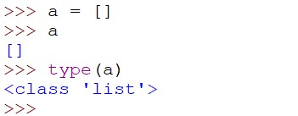

Another example:

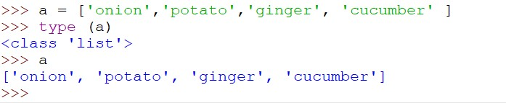

We firstly stored nothing in a = []. So it was an empty list.

After that we use

a = ['onion','potato','ginger', 'cucumber’]. Here we store four item in a single list. Items data type can be string, integer, Boolean or any data type.

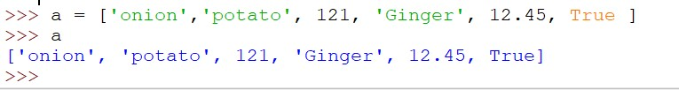

here variable ‘a’ stores string, integer, float, Boolean and print it at a same time. Remember you need to use quote only for string data type.

1. Access Item:

we already know that index of string is counted from 0. Like same index of lists are also counted from zero.

|  |
| --- |
| ***Index of List*** |

|  |  |  |  |  |  |
| --- | --- | --- | --- | --- | --- |
| 0 | 1 | 2 | 3 | 4 | 5 |



Now check every single index of variable ‘a’

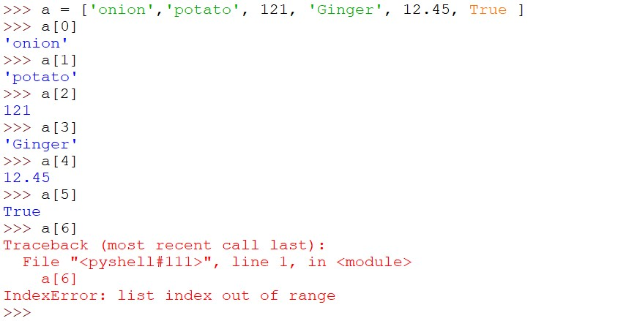you can also check the data type of every item. Write 🡪 type(a[0]) . Do it yourself.

1. Update List

We can update our item by replacing new item in it. If we need to replace Onion by rice:

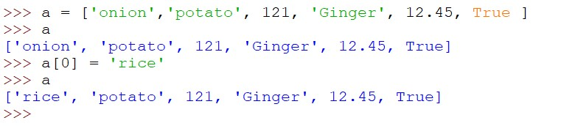

Wow! we have successfully changed the 0th index

1. Remove Item

You can remove item by remove () function and del () function

Function del needs the index number and function remove

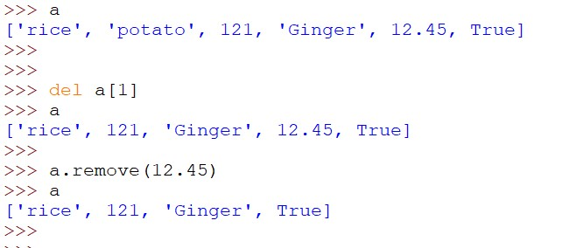Needs the item name.

Tuple

Tuple is also one kind of list. But both are not same. You will learn this in higher grade. We are just talking about the very basic. You need first bracket to declare tuple.

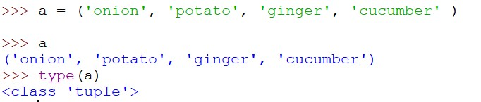

1. Access Item

Accessing item in tuple is same as list. Just use second bracket. But if you want to check value of a specific index or specific data type you have to use third bracket. Here is an example:

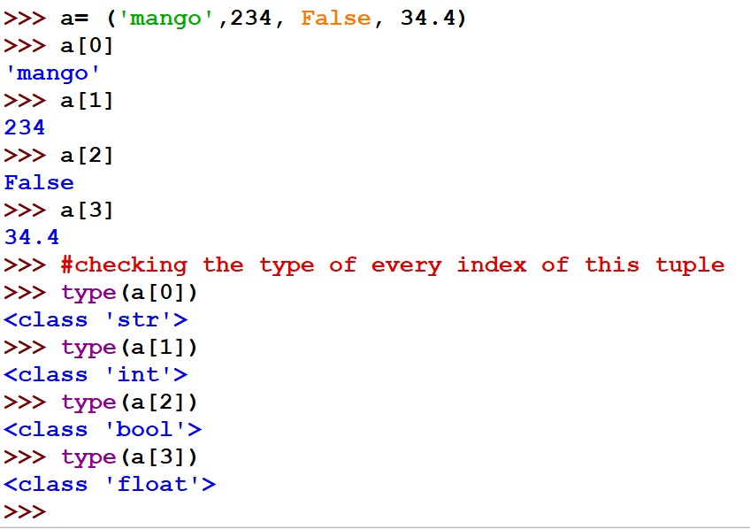

1. Changing Item

You cannot replace item in tuple like list. But you can add new item in it.

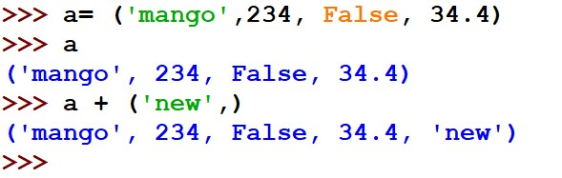

Set

Set is also a data type like list. You may compare it with the set you learn in Mathematics. The funny part is, like mathematics set Python has the same operation of Union, Intersection and Difference.

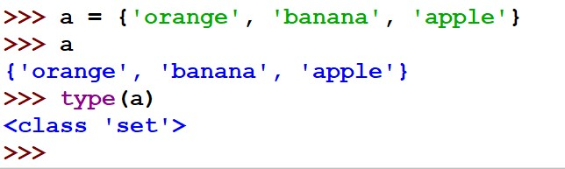

1. Access Item

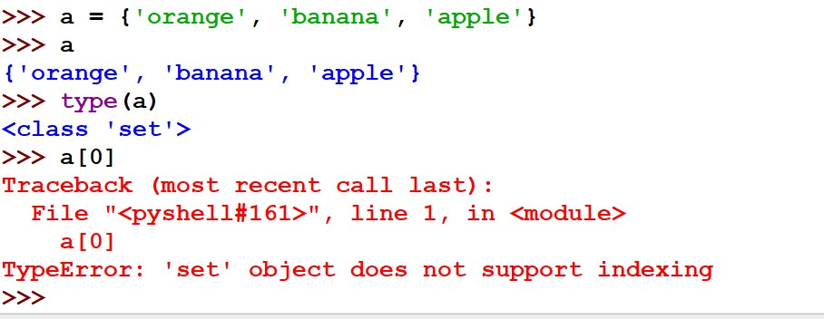The value of set cannot be accessed by indexing.

But you can add item in it using add function.

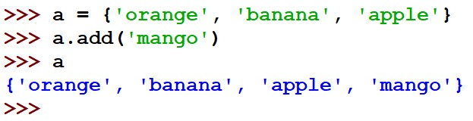

1. Removing Item

You can delete specific item using remove function. Also you can delete the first one of item using pop () function. Besides you can delete everything from set using clear function.

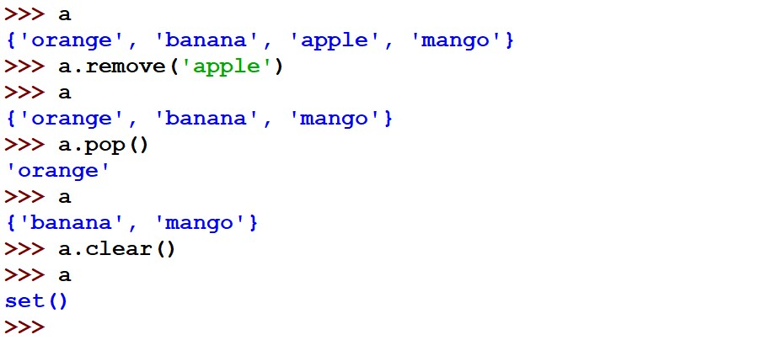

You will learn union, intersection and set difference in higher class. Stay happy till then and be an awesome python programmer.